High School Students’ Growth in EFL Vocabulary Size Estimated By Vocabulary Quotient

Hong-Fa Ho
Department of Applied Electronics Technology, National Taiwan Normal University, Taipei 10610, Taiwan, R.O.C.
jackho@ntnu.edu.tw

Abstract: Insufficient English vocabulary size accounts for one of the common learning problems in EFL (English as a Foreign Language) students. Some researchers identified vocabulary growth as a major challenge for EFL students. This study compared vocabulary test scores between junior and senior high school students, and used the score difference to estimate high school students’ growth in vocabulary size. To convert the raw data of the student’s test scores to an indicative vocabulary size measure for teaching and learning purposes, this study applied a key performance indicator method called Vocabulary Quotient (VQ) to estimate participants’ vocabulary size. This study demonstrated that vocabulary quotient is a useful key performance indicator in English vocabulary teaching and learning. By quickly accessing the individual vocabulary size, teachers are able to adjust the course curriculum and fit to the student’s pace. Because in average the participants had a lower vocabulary growth in spelling than reading and listening, English teachers may consider strengthening the students’ weakest area, which is spelling in this study. Although the mean value of the participant’s vocabulary size had achieved up to 80 percent of the national recommendations, there are still existing English proficiency gaps among students. The findings provided an insight that the vocabulary growth sizes of EFL high school students in Taiwan were highly affected by the national recommendations. The lexical thresholds need to consider not only the inequity of the lower English proficiency students, but also providing encouraging environment for higher achieving students.

Keywords: English as a Foreign Language (EFL); vocabulary quotient (VQ); vocabulary test; vocabulary size

- INTRODUCTION
There are more than one billion people learning English as a Foreign Language (EFL) globally . In many countries, English became an official language or considered as an educational priority in school curriculums . Most high school students proceed to university studies, the abilities often required are online literature research and reading English textbooks. stated that English vocabulary accounts for one important contributing factor for good English proficiency. Empirical studies also suggested the importance of sufficient vocabulary size in acquiring English language skills . The adequate vocabulary size for wide-ranging text coverage was found to be associated with optimal and minimum lexical threshold of the education goals .

A framework of lexical development addressed the importance of pedagogical balance between promoting explicit and encouraging implicit vocabulary learning strategies for all level of EFL learners . Three vocabulary learning strategies were noted by (1) vocabulary growth is influenced by individual’s knowledge of the world, especially in various disciplines and technical vocabulary; (2) a good vocabulary growth strategy required broad vocabulary knowledge; and (3) teachers play an important role in direct teaching of high frequency vocabulary to indirect encouragement of low frequency vocabulary. Among Taiwanese university freshman, using a monolingual dictionary is the most used strategy and using a bilingual dictionary is the least used strategy . In current national English curriculum, deliberate learning from word list and card is still a dominant way in speedy vocabulary acquisition . However, contextualized strategies by means of watching English news and extensive reading are vital parts for students to involve in practical foreign language learning . For example, the curriculum time balance of the four strands including meaning input, meaning output, language learning, and fluency development by provided a framework for contextualized language course management.

To evaluate student’s vocabulary growth, many English vocabulary assessment tools were developed including Vocabulary Levels Test ; Eurocentres Vocabulary Size Test ; and V-Size concept with computer software , where the e-rater software measured the learner’s vocabulary size and writing ability . Most vocabulary assessment tools tested on students’ vocabulary spelling, recognition, and usage . However, Yes/No type questions in word recognition tests were criticized by its high 50-50% guess rate, multiple choice questions were then used in this study as a better alternative . After the English vocabulary tests, some studies concerned the problem of unusable scores and considered more effective measurements of the learner’s vocabulary state . This study hence adopted a vocabulary quotient (VQ) method in a self-developed computer test system. VQ, was originally derived from a concept of Chinese character quotient , is one kind of KPI (Key Performance Indicator) vocabulary assessment method. Different from Chinese character quotient, VQ was used in EFL teaching and learning evaluations with proven validity and reliability . VQ method is able to estimate English vocabulary size with positive correlated test scores of computer tests on keyboard spelling, visual reading, and audio listening.

Reading and listening are two main sources for English vocabulary assessments. found the Matthew’s reading effect on individual’s reciprocal language learning between reading ability and vocabulary ability. Others with the similar view found that 1000 learned vocabulary contributed to 72% of reading text coverage and 15851 vocabulary contributed to 97.8% text coverage . Listening is another required ability in a real life English conversation . In listening vocabulary assessments, some dialogue questions assessed students’ listening comprehension without the features of pronunciation or with features of audio word recognition test . Considering the importance of reading and listening in English vocabulary assessments, and the lack of findings on proven vocabulary assessment tools , this study adopted the method of VQ in a self-developed computer test models in spelling, reading, and listening. Using the self-developed vocabulary test software system, this study aim to compare vocabulary test scores between junior and senior high school students, and used the score difference to estimate high school students’ growth in vocabulary size. The vocabulary size is able to give a simple and standardized comparison between groups and for teaching and learning evaluation.

Three research questions were considered:
Q₁: What is the growth in vocabulary size between junior and senior high school student levels in three test models of spelling, reading, and listening?
Q₂: What is the least growth in vocabulary size in the three test models of spelling, reading, and listening?
Q₃: What is the most growth in vocabulary size in the three test models of spelling, reading, and listening?

The Ministry of Education in Taiwan recommended a list of 2200 word families which is a lexicon for junior high school textbooks. For senior high schools, 7000 word families were recommended by College Entrance Examination Centre in Taiwan. High school curriculum and textbooks are based on the recommended vocabulary list; therefore, it was our intention to examine the effects of the national recommendation on students’ vocabulary size. In other words, the students may be susceptible to 4800 words learning constraint studying from junior to senior high school level. The National Spelling Competition was held every year to test on Taiwanese students’ vocabulary proficiency at all school levels. Junior and senior high school students are two test groups of the interest in this study, therefore, the test result differences between groups were used to estimate high school student’s growth in vocabulary size. Junior high school students were tested on the 2200 word families and senior high school students were tested on the 4800 words difference by subtracting 2200 from 7000 word families. The growth in vocabulary size is expected to be less than 4800 words between junior and senior high school student levels, this study thus proposed Hypothesis H_{1.} Hypothesis H2 was proposed due to spelling required more memory than selecting multiple choice answers in reading and listening test. Hypothesis H₃, reading has the most growth in vocabulary size than spelling and listening, was proposed due to English learning environment in Taiwan: (1) students are taught in Chinese speaking classrooms; (2) listening has the least amount of practice time; and (3) reading is taught in English paragraph with longer study time than listening. Hence, the study proposed reading has the most growth in vocabulary size.

Three hypotheses are proposed:
H₁: The growth in vocabulary size is less than 4800 words between junior and senior high school student levels in three test models of spelling, reading, and listening.
H₂: Spelling has the least growth in vocabulary size in the three test models of spelling, reading, and listening.
H₃: Reading has the most growth in vocabulary size in the three test models of spelling, reading, and listening.

- METHOD
  - Participants
A total number of 1938 participants contested in a 2010 National Spelling Competition in Taiwan. The students were selected from 276 different high schools, including 1156 students from 169 junior high schools and 782 students from 107 senior high schools. Table I shows the grade composition and the number of students of two test groups. To enter the competition, English teachers of each school recommended students with good English proficiency with class attendance of more than three years for junior high and more than five years for senior high school students.

TABLE II PARTICIPANTS OF TWO TEST GROUPS (N=1938)
Test Group | Junior High | Senior High
Grade | Grade 7th~9th | Grade 10th~12th
n | 1156 | 782

  - Materials
2010 National Spelling Competition was held to test junior high school students on 2200 word families and to test senior high school students on 4800 words (subtract 2200 from 7000 word families). The competition is a computerized test that consisted of three test models: (1) spelling, (2) reading, and (3) listening. Each test model has 100 questions with a total model point of 100. The computer randomly selected 300 test questions without repetition. The test scores were then examined with the VQ method to estimate the students’ growth in vocabulary size between two test groups. The vocabulary sizes were estimated by the computer system based on defined variables of a VQ function: (VQ (p, m, L, t, z) = {VQ_{i} | 1≤i ≤d}), where p is the examinee, m is the native language of p, such as Chinese in this study, L is the set of target English vocabulary, t is the date of the test, z is the number of test items for each test model, and z is a positive integer, VQ_{i} is the quotient of the number of correct answers divided by z of some specific test model i about English vocabulary in L, and d is the number of different test models . Note that, the target English vocabulary is selected randomly from L by using the uniform distribution random function.

  - Tools
English vocabulary test software consists of three test models (Table III): (1) spelling, (2) reading, and (3) listening test. Test model symbols were denoted as the following: (1) E_{t} is a target English vocabulary; (2) E_{x}, E_{y}, and E_{z} are non-target English vocabulary, x≠y≠z≠t; (3) C_{p} (E_{t}) is a corresponding Chinese meaning of the E_{t}; (4) V (E_{t}) is an English pronunciation of the E_{t}; (5) Len (E_{t}) is a length of the E_{t}, which is the number of letters used to spell the target English word; and (6) C_{q}, C_{r}, and C_{s} stand for other Chinese meanings, where p≠q≠r≠s.

In spelling test, students spell out and type in the target English vocabulary after pronunciations are given. In reading test, students choose correct vocabulary in multiple choice questions related to the reading context. In listening test, students choose correct vocabulary in multiple choices after pronunciations are given.

TABLE IV THREE TEST MODELS OF ENGLISH VOCABULARY TEST
Test Model | Description
Spelling test | Given C_{p} (E_{t}), Len (E_{t}), and V (E_{t}).  Examinee is asked to key-in E_{t}.
Reading test | Given E_{t} and the choices of C_{p} (E_{t}), C_{q}, C_{r} and C_{s} in random sequence. C_{p} (E_{t}) was the target choice, and C_{q}, C_{r} and C_{s} were the wrong choices.  Examinee was asked to choose the target choice.
Listening test | Given V (E_{t}) and the choices of C_{p} (E_{t}), C_{q}, C_{r} and C_{s} in random sequence. C_{p} (E_{t}) was the best choice which matched the given V (E_{t}). C_{q}, C_{r} and C_{s} were the wrong choices.  Examinee was asked to choose the target choice.

The use of Statistical Package SPSS V.18 provided descriptive statistics on mean score and standard deviation of the three tests.

  - Design
The study is a 2×3 factorial design to examine the recent English vocabulary growth size among junior and senior high school students by comparing three test scores of spelling, reading, and listening. The first independent variable is the grade of students (junior, senior). The sencod independent variable is the vocabulary test model (spelling, reading, and listening). There are three dependent variables: vocabulary size of spelling, vocabulary size of reading, and vocabulary size of listening. The VQ method was used to estimate the vocabulary size of the three dependent variables.

  - Procedure
The study was conducted with 2010 National Spelling Competition in Taiwan. Participants contested in a computer English vocabulary test program designed by the author. Before the tests, all participants familiarized with test system such as earphones and computer software in a computer room. Three hundred questions of three test models were randomly tested in an order of spelling, reading, and listening; one hundred questions from each model finished in 20, 10, and 10 minutes for spelling, reading, and listening, respectively. The computer software recorded the test scores (0-100 points) with the VQ method for the vocabulary size estimation.

- FINDINGS AND DISCUSSION

The test score presented in a horizontal axis and number of participants on a vertical axis (Figure 1 and Figure 2). Distribution curves of the model scores all negatively skewed in both Figure 1 and Figure 2. The histogram distributions indicated the majority of students were above average scores of the English vocabulary test in spelling, reading, and listening. Senior high school students had generally increased vocabulary test scores in all three tests compared to junior high school students.
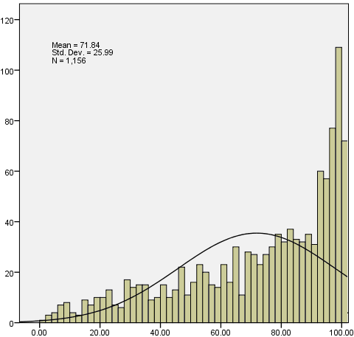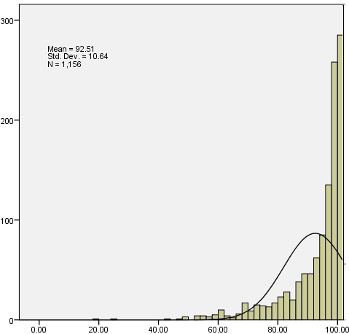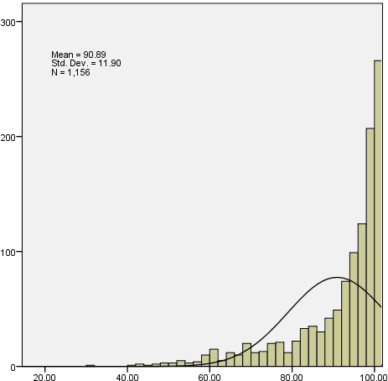
(a) Spelling. (b) Reading. (c) Listening.
Fig. 1 Histogram distribution of the test model scores for junior high school students

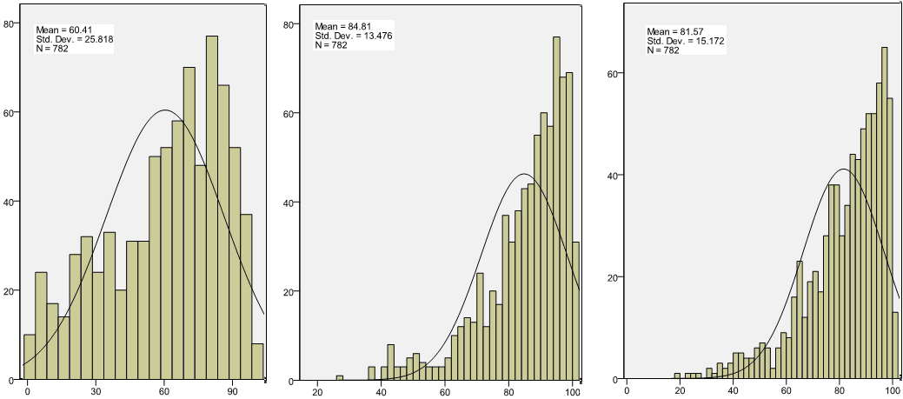
(a) Spelling. (b) Reading. (c) Listening.
Fig. 2 Histogram distribution of the test model scores for senior high school students

Table V summarizes the calculated mean and standard deviation (SD) for two test groups. The mean scores of the three tests in descending order are reading, listening, and spelling. Spelling had the lowest mean scores and twice SD (26 points) than reading and listening (13 points).

TABLE VI MEAN VOCABULARY TEST SCORE (IN POINTS) OF THREE TEST MODELS
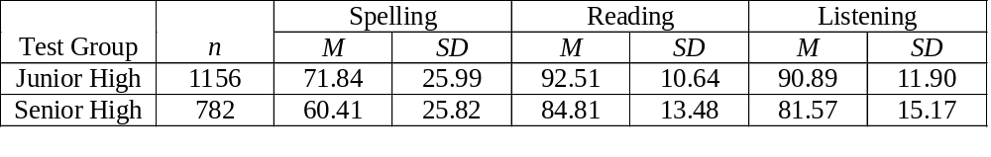
After comparing the test results, the author used the VQ method to estimate minimum, maximum, and mean vocabulary size of the participants shown in Table VII. The mean difference between junior and senior high-test groups subtracted to get a growth in vocabulary size. The growth sizes estimated to be 3591, 4328, and 4206 in spelling, reading, and listening, respectively. The estimated sizes were about one-fourth of native speakers who has comparatively high 20,000 vocabulary in tertiary education . Because the growth size of EFL students in spelling, reading, and listening were less than 4800 words, the study hypothesis H₁ was supported. H₂ and H₃ were supported by the findings that spelling had the least growth in vocabulary size and reading had the most growth in vocabulary size. The growth rate of spelling, reading, and listening were also calculated to about 1197, 1443, and 1402 words per year, respectively. The mean growth rate was compared half to the bidialectal speakers of Hawaiian Creole English and standard English, who had a growth rate of more than 3,000 vocabulary per year .

TABLE VIII MEAN VOCABULARY SIZE (IN WORDS) ESTIMATED BY VQ
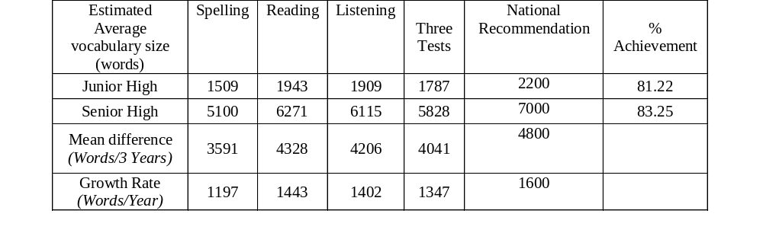
Figure 3 used box plot graphic to present the different estimated VQ value of vocabulary size in spelling, reading, listening between the two test groups. The bottom line, the upper line, and the middle point represent the minimum, the maximum, and the mean of the estimated vocabulary size among the participants. The findings suggested that the participants had general better vocabulary performance and had a growth difference of about 200 words per year in reading and listening greater than spelling. Large vocabulary size gaps between individuals also existed in all aspects of spelling, reading, and listening.

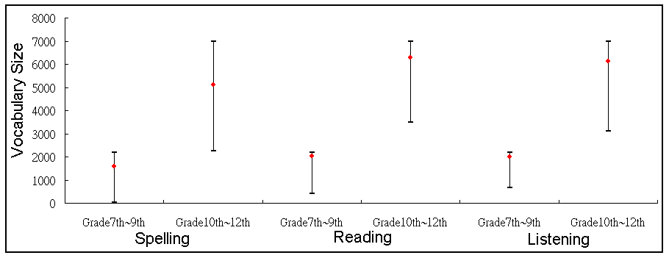
Fig. 3 Minimum, maximum, and mean of vocabulary sizes of three aspects between two test groups

- CONCLUSION

The study evaluated students’ vocabulary acquisition provided that the high school curriculum and textbook are based on the national recommended vocabulary from The Ministry of Education (2200 word families in junior high) and College Entrance Examination Center (7000 word families in senior high) in Taiwan. The findings contributed to educational applications in vocabulary size theories and practices. This study adopted the method of vocabulary quotient in a self-developed computer test models in spelling, reading, and listening. Using the self-developed vocabulary test software system, this study estimated the vocabulary growth between junior and senior high school students in Taiwan. The test scores from the system calculated to a more precise vocabulary size measure. The correct estimate of vocabulary size is able to give a simple and standardized comparison between groups as well as a tool for future teaching and learning evaluation. The findings included: (1) the vocabulary size of EFL students in spelling, reading, and listening increased 3591, 4328, and 4206 words, respectively. The mean growth had close to but no more than 4800 words that are recommended to study from junior to senior high schools; (2) spelling had the least growth in vocabulary size; (3) reading had the most growth in vocabulary size. The results indicated despite the mean value of the participant’s vocabulary size had achieved up to 80 percent of the national recommendations, there is still large English proficiency gaps among individuals.

  - Implication
This study demonstrated that vocabulary quotient is a useful key performance indicator in English vocabulary teaching and learning. Using vocabulary quotient as a key performance indicator, EFL teachers can identify early if the student had insufficient vocabulary size. By applying the vocabulary quotient method, teachers are able to evaluate the student’s vocabulary size before, during, or after the school curriculum. By quickly accessing the individual vocabulary size, teachers are able to adjust the course curriculum and to fit to the student’s pace. The participants had a lower vocabulary growth in spelling than reading and listening, English teachers may consider strengthening the students’ weakest area, which is spelling in this case.

Despite the mean value of the participant’s vocabulary size had achieved up to 80 percent of the national recommendations, there are still existing English proficiency gaps among students. The wide standard deviation indicated the inequity and Matthew effects existing in the participants, namely, the reciprocal effects were strong between the insufficient vocabulary size and the English reading proficiency. Therefore, the insufficient vocabulary size of the participants has restricted their continuing English acquisition. The findings have provided an insight that the vocabulary growth size of EFL high school students in Taiwan was highly associated with optimal 7000 word families and minimum 2000 word families lexical threshold of the national recommendation. It is suggested the policy makers may consider not only the learning burden of the lower English proficiency students, but also an encouraging environment for higher achieving students with more than one vocabulary recommendation list in order to increase the vocabulary threshold in high school student population.

  - Limitations
The vocabulary test software is limited to test percipients on national recommended vocabularies in Taiwan and with most test models in decontextualized form. The method of vocabulary quotient is limited for comparisons between similar population background and required variable adjustments in the function of vocabulary quotient. Although the proposed vocabulary quotient could apply to other languages with modifications, the method of vocabulary quotient is still limited for universal comparison and may only complement for international comparison when other international standard such as English Proficiency Index (EPI) is not available.

  - Scope of Further Study
The study validity needs further approval by including larger population size and further improvement by adding speaking assessment for future research once a compatible English vocabulary voice recognition technology became available. The study findings in student’s growth in vocabulary size could consider longitudinal study to evaluate individuals’ achievement in following national recommendation as a more precise national curriculum assessment. Contextualized curriculum assessment is in imperative need for Taiwanese EFL high school student to fulfill the language learning balance of the four strands, namely, meaning input, meaning output, language learning, and fluency development.

ACKNOWLEDGEMENTS
This research is partially supported by the“Aim for the Top University Project” of National Taiwan Normal University (NTNU), sponsored by the Ministry of Education, Taiwan, R.O.C. and the “International Research-Intensive Center of Excellence Program” of NTNU and National Science Council, Taiwan, R.O.C. under Grant no. NSC 103-2911-I-003-301.

REFERENCES
[1] M. Clyne and F. Sharifian, "English as an international language: challenges and possibilities," Australian Review of Applied Linguistics, vol. 31, 2011.
[2] W. Chang, H. Yeh, S. Joe, Y. You, C. Chern, and M. Liao, "The investigation of the influence of English teaching from the policy of Taiwan English education," in Selected papers from the proceedings of 2007 international conference and workshop on TEFL & applied linguistics compiled by Department of Applied English Ming Chuan University, 2007, pp. 672-686.
[3] R. L. Bransdorfer, "DESIGNING LANGUAGE TEACHING TASKS," ed: Cambridge Univ Press, 2004.
[4] Y. Attali and J. Burstein, "Automated essay scoring with e-rater® V. 2," The Journal of Technology, Learning and Assessment, vol. 4, 2006.
[5] L. S. Stæhr, "Vocabulary size and the skills of listening, reading and writing," Language Learning Journal, vol. 36, pp. 139-152, 2008.
[6] B. Laufer and G. C. Ravenhorst-Kalovski, "Lexical threshold revisited: Lexical text coverage, learners' vocabulary size and reading comprehension," Reading in a Foreign Language, vol. 22, pp. 15-30, 2010.
[7] A. Hunt and D. Beglar, "A Framework for Developing EFL Reading Vocabulary," Reading in a Foreign language, vol. 17, pp. 23-59, 2005.
[8] R. Schreuder and B. Weltens, The Bilingual Lexicon: John Benjamins Publishing Company, 1993.
[9] T. Cheng-Chang and I. C. Chang, "An Examination of EFL Vocabulary Learning Strategies of Students at the University of Technology of Taiwan," International Forum of Teaching & Studies, vol. 5, pp. 32-38, 2009.
[10] I. Elgort, "Deliberate Learning and Vocabulary Acquisition in a Second Language," Language Learning, vol. 61, pp. 367-413, 2011.
[11] Q. Wang, "The National Curriculum Changes and Their Effects on English Language Teaching in the People’s Republic of China," in International Handbook of English Language Teaching. vol. 15, J. Cummins and C. Davison, Eds., ed: Springer US, 2007, pp. 87-105.
[12] P. Nation, "The Four Strands," Innovation in Language Learning and Teaching, vol. 1, pp. 2-13, 2007/04/16 2007.
[13] I. S. P. Nation, "Teaching & learning vocabulary," 2013.
[14] P. Nation and T. Chung, "28 Teaching and Testing Vocabulary," The handbook of language teaching, p. 543, 2009.
[15] P. Meara and B. Buxton, "An alternative to multiple choice vocabulary tests," Language Testing, vol. 4, pp. 142-154, 1987.
[16] P. Meara and G. Jones, "Eurocentres vocabulary size test 10KA," Zurich: Eurocentres Learning Service, 1990.
[17] P. Meara, "Designing vocabulary tests for English, Spanish and other languages," PRAGMATICS AND BEYOND NEW SERIES, vol. 140, p. 271, 2005.
[18] M. K. Enright and T. Quinlan, "Complementing human judgment of essays written by English language learners with e-rater® scoring," Language Testing, vol. 27, pp. 317-334, 2010.
[19] M. Harrington, "The Yes/No test as a measure of receptive vocabulary knowledge," Language Testing, vol. 23, pp. 73-98, 2006.
[20] I. Huibregtse, W. Admiraal, and P. Meara, "Scores on a yes-no vocabulary test: Correction for guessing and response style," Language testing, vol. 19, pp. 227-245, 2002.
[21] R. Beeckmans, J. Eyckmans, V. Janssens, M. Dufranne, and H. Van de Velde, "Examining the Yes/No vocabulary test: some methodological issues in theory and practice," Language Testing, vol. 18, pp. 235-274, 2001.
[22] J. Eyckmans, "Measuring receptive vocabulary size," Utrecht: LOT. OpenURL, 2004.
[23] M. Rosa, "Don’t cha know? A survey of ESL teachers’ perspectives on reduced forms instruction," Second Language Studies, vol. 21, pp. 49-78, 2002.
[24] L. Cameron, "Measuring vocabulary size in English as an additional language," Language Teaching Research, vol. 6, pp. 145-173, April 1, 2002 2002.
[25] J. Read, Assessing vocabulary: Cambridge University Press Cambridge, 2000.
[26] H.-F. Ho and P.-Z. Lin, "Chinese character Learning Review System with Item Response Theory Analysis," 2010.
[27] H.-F. Ho and C. Huong, "A Multiple Aspects Quantitative Indicator for Ability of English Vocabulary: Vocabulary Quotient," Journal of Educational Technology Development & Exchange, vol. 4, 2011.
[28] K. E. Stanovich, "Matthew effects in reading: Some consequences of individual differences in the acquisition of literacy," Journal of education, vol. 189, 2008.
[29] B. Laufer, "What percentage of text-lexis is essential for comprehension," Special language: From humans thinking to thinking machines, pp. 316-323, 1989.
[30] D. Hirsh and P. Nation, "What vocabulary size is needed to read unsimplified texts for pleasure?," Reading in a foreign language, vol. 8, pp. 689-689, 1992.
[31] J. Field, "Promoting perception: lexical segmentation in L2 listening," ELT journal, vol. 57, pp. 325-334, 2003.
[32] Y. Ito, "Effect of reduced forms on ESL learners’ input-intake process," Second language studies, vol. 20, pp. 99-124, 2001.
[33] H.-M. Chen and S.-H. Cheng, "An investigation on the listening difficulties of technical college students in Taiwan," 中華技術學院學報, pp. 335-361, 2007.
[34] L. Bourke and A.-M. Adams, "The relationship between working memory and early writing assessed at the word, sentence and text level," Educational and Child Psychology, vol. 20, pp. 19-36, 2003.
[35] T. G. White, M. A. Power, and S. White, "Morphological analysis: Implications for teaching and understanding vocabulary growth," Reading Research Quarterly, pp. 283-304, 1989.

Hong-Fa Ho received the Ph.D. degree in electrical engineering from National Taiwan University, Taipei, Taiwan, R.O.C., in 1990. His research interests include educational technology and engineering education.

